Eylul Turkay
3975 words

BIO 604 DISSERTATION
Supervisor: Tania Maffucci
Eylul Turkay
220097611

Table of Contents
Targeting Metabolic Plasticity in PDAC: A Dual Approach Using Glycolytic Inhibitors and CRISPR-Cas9-Mediated OXPHOS Disruption to Overcome Therapeutic Resistance 1
1. Introduction 1
2. Pathophysiology and Metabolic Adaptation in PDAC 2
2.1 Genetic and Molecular Landscape 2
2.2 Tumour Microenvironment and Crosstalk 3
2.3 Metabolic Plasticity in Context 5
3. Metabolic Reprogramming in PDAC 7
3.1 Glycolysis & the Warburg Effect 7
3.2 Key Glycolytic Enzymes 8
3.3 Mitochondrial Metabolism & OXPHOS 11
4. Treatment Landscape and Limitations 13
4.1 Current Conventional Therapies 13
4.2 Chemotherapy-Induced Metabolic Shifts 16
5. Targeting Metabolism in PDAC: Current & Emerging Approaches 18
5.1 Pharmacological Inhibitors of Glycolysis and OXPHOS 18
5.2 CRISPR-Based Metabolic Gene Editing 24
6. Discussion 28
7. Conclusion 29
8. Acknowledgements 29
9. References 30

Targeting Metabolic Plasticity in PDAC: A Dual Approach Using Glycolytic Inhibitors and CRISPR-Cas9-Mediated OXPHOS Disruption to Overcome Therapeutic Resistance

1. Introduction (323)
Pancreatic cancer encompasses a group of malignancies that originate within the pancreas, an organ critical for both digestive enzyme production and glucose regulation. Among these, pancreatic ductal adenocarcinoma (PDAC) stands out as the most aggressive and prevalent subtype, accounting for 90% of all cases. Tumours in this organ often remain asymptomatic until they reach advanced stages, resulting in diagnosis at an advanced stage where curative options are limited. Consequently, PDAC has one of the poorest prognoses with a five-year survival rate below 10% and projections estimating it will become the second leading cause of cancer-related deaths by 2030 (Vasseur et al., 2010; Zhang et al., 2023).
The adverse outcomes associated with PDAC stem not only from late detection and rapid metastasis but also tumour’s ability to switch between metabolic pathways such as glycolysis and oxidative phosphorylation (OXPHOS) in response to environmental and therapeutic stress. This metabolic flexibility enables tumour cells to maintain energy homeostasis under adverse conditions, including hypoxia or nutrient deprivation, thereby regulating survival and continued proliferation.
Although standard treatments, such as chemotherapy, have improved short-term outcomes, emergence of resistance limits their long-term efficacy, necessitating the development of alternative strategies. This has led to increased interest in therapeutic strategies that co-target metabolic pathways to prevent compensation. In this context, a promising approach includes the simultaneous inhibition of glycolysis and OXPHOS.
Recent advancements in gene editing technologies particularly CRISPR -Cas9, offer promising solutions for modulating key metabolic pathways, enabling a precise disruption of key components of OXPHOS pathways. By combining inhibitors of glycolysis, researchers aim to target dual strategies simultaneously to attack on tumour metabolism.
This dissertation explores a dual-targeting strategy that combines pharmacological inhibitors of glycolysis and CRISPR-Cas9-mediated disruption of mitochondrial metabolism. This study aims to evaluate whether this combined approach can effectively disrupt metabolic plasticity and enhance therapeutic outcomes. The following chapters will first provide an overview of PDAC biology, metabolic basis of resistance and current treatment limitations before exploring the therapeutic potential of this combined intervention.

2. Pathophysiology and Metabolic Adaptation in PDAC

2.1 Genetic and Molecular Landscape 291
PDAC is characterised not only by its clinical aggressiveness but also by a complex and heterogenous genetic profile that underscores its resistance to treatment
More than 90% of PDAC tumours include activating mutations in the proto-oncogene KRAS, which leads to uncontrolled proliferation activates signalling pathways such as PI3K/AKT, MAPK, and TGF-β pathways. These pathways do not function in isolation, instead they collectively contribute to tumour growth, rewiring and evasion of cell death (apoptosis). In parallel, the inactivation of tumour suppressor genes such as TP53, CDKN2A, and SMAD4, disrupts cell cycle regulation and enhance cellular survival under therapeutic pressure. This combined effect of these mutations creates a tumour microenvironment (TME) that is biologically aggressive and highly adaptable, complicating to identify a single dominant mutation. PDAC’s mutational landscape leads to diverse oncogenic outputs across patient posing a challenge to personalised treatment strategies (Sarantis et al., 2020).
Clinically, this molecular complexity manifests in the tendency of PDAC diagnosed at advanced stages (stages 3 and 4), when tumours have already invaded major vascular structures or metastasised to distant organs. As illustrated in Figure 1, early-stage tumours may still be resectable but most patients present with locally advanced or metastatic disease where surgical option is no longer feasible. At this point, systemic chemotherapy becomes the primary mode of treatment however, the efficacy of such therapies is undermined by tumour’s ability to resist apoptosis and adapt metabolically. The resistance is not merely due to mutations, it is actively reinforced by tumour’s ability to reprogram its metabolism. Mutant KRAS, for example supports both proliferation and glycolysis helping cells survive under stress. These genetic changes also shape the TME, laying the foundation for the metabolic flexibility explored in the next sections.
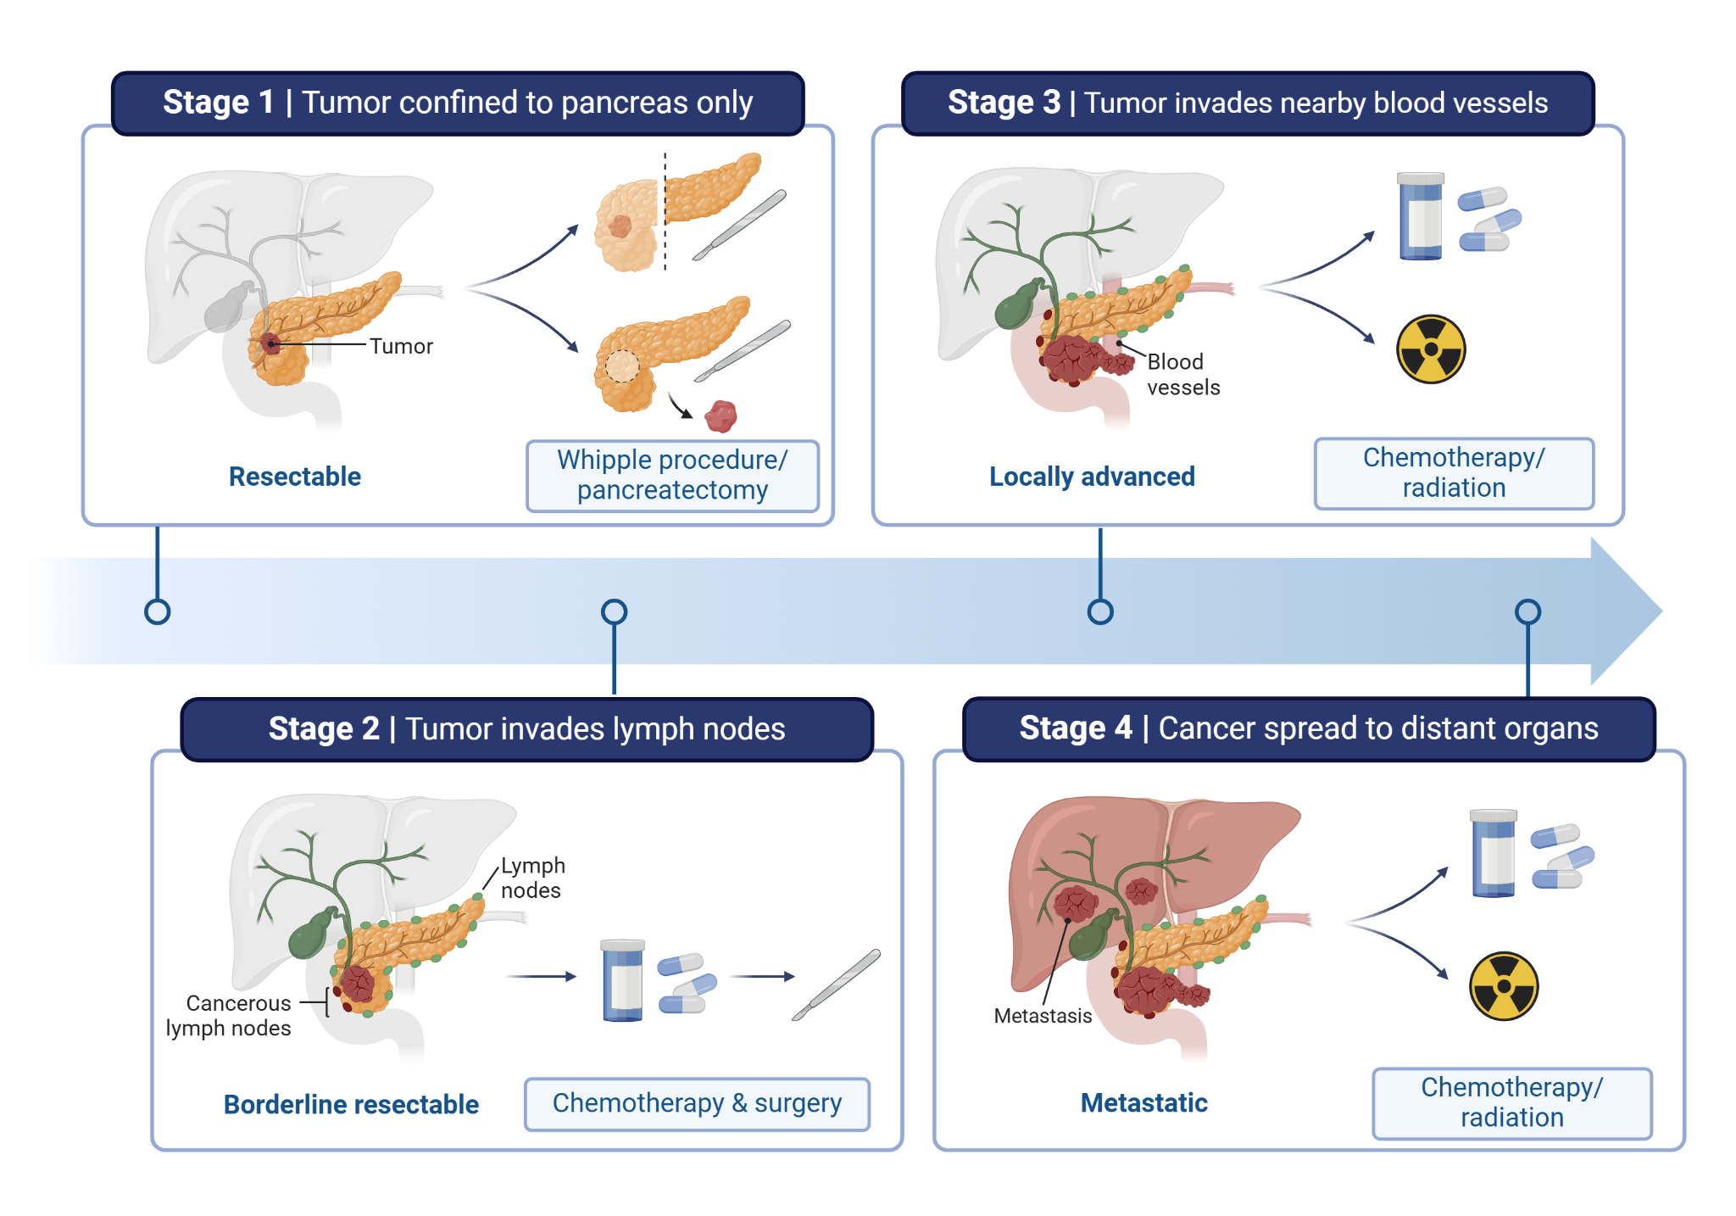
Figure 1. Clinical stages of pancreatic cancer and associated treatment strategies. The figure outlines four stages of pancreatic cancer, from localised disease to metastasis. In stage 1, the tumour is confined to the pancreas only and considered resectable. The Whipple procedure is the preferred option for treatment. Stage 2 involves invasion of lymph nodes and may still be operable. It is often treated with neoadjuvant therapy followed by surgery. Stage 3 includes invasion of nearby blood vessels, and this stage is considered locally advanced and considered unresectable, with chemotherapy or radiation as the only option for treatment. Stage 4 represents distant metastasis to organs like the liver or lungs and is managed with palliative care or radiotherapy. Due to silent progression and late onset, PDAC is often diagnosed at stage 3 or 4, when the therapeutic options are limited, and the tumour exhibits significant metabolic plasticity and resistance.

2.2 Tumour Microenvironment and Crosstalk 311
In addition to its complex mutational profile, PDAC exhibits a highly specialised and hostile TME, playing a central role in therapeutic resistance. PDAC present extensive desmoplasia, a fibrotic reaction characterised by dense extracellular matrix (ECM), abundant cancer-associated fibroblasts (CAFs), and immune cell exclusion (Fu et al., 2018). This environment impairs drug penetration and reduce immune surveillance, thereby enabling tumour survival and progression (Zhang et al., 2023).
A major consequence of this desmoplastic environment is hypoxia, which emerges from poor vascularisation and high interstitial pressure. In response, tumour cells stabilise hypoxia-inducible factor-1α (HIF-1α), a key transcriptional factor that drives metabolic reprogramming and suppressed apoptosis. By upregulating genes involved in anaerobic metabolism, HIF-1α enhances tumour’s ability to generate ATP and biosynthetic precursors in oxygen-deprived conditions, thus enforcing the metabolic plasticity of PDAC (Vasseur et al., 2010; Dong et al., 2022).
Importantly, stromal cells, specifically CAFs and pancreatic stellate cells (PSCs), also shape metabolic profile of PDAC (Fu et al., 2018). PSCs, quiescent in a healthy pancreas, become activated by tumour-deprived signals and differentiate into CAFs (Fu et al., 2018). These CAFs engage in metabolic crosstalk with tumour cells, via monocarboxylate transporters (MCT4 in CAFs and MCT1 in tumour cells), facilitating the transfer of metabolic byproducts such as lactate and pyruvate for OXPHOS usage (Benjamin and Hall, 2022). In addition to lactate, CAFs supply alternative fuel sources including glutamine and branched-chain amino acids (BCAAs), which feed into biosynthetic and redox pathways sustaining tumour proliferation (Li et al., 2023). This metabolic exchange allows PDAC cells to bypass the reliance on glucose and maintain growth under therapeutic pressure or nutrient deprivation. These interactions support the tumour metabolism as well as sustains the tumour’s hostile environment and resistance to treatment (Li et al., 2023).
As depicted in Figure 2, CAFs are heterogenous, comprising subpopulations contribute to fibrosis, immune evasion and nutrient support, creating a TME that reinforces resistance (Li et al., 2023).
Together, tumour-stroma interactions in PDAC create a metabolically flexible and treatment resistance niche. Targeting this metabolic symbiosis represents a promising strategy that complements tumour-intrinsic metabolic targeting.

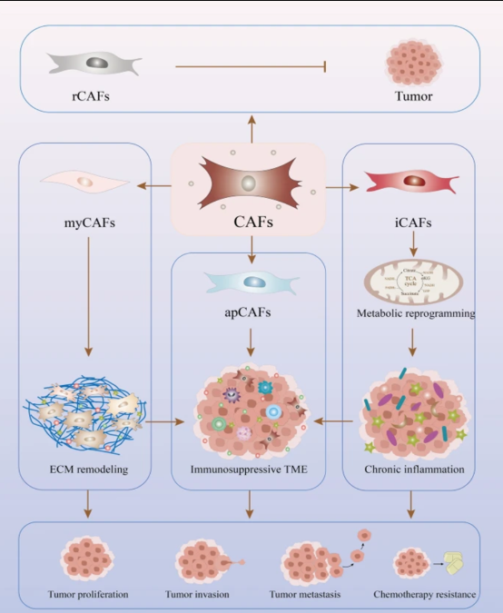
Figure 2. Shows CAFs exist in heterogeneous subtypes with distinct functions. Myofibroblastic CAFs (myCAFs) promote extracellular matrix remodelling and fibrosis, whereas inflammatory CAFs (iCAFs) secrete high levels of cytokines, including IL-6 and IL-11, that fuel tumour progression and immune modulation. Antigen-presenting CAFs (apCAFs) regulate immune evasion, whereas metabolically active CAFs (meCAFs) support PDAC metabolism by enhancing nutrient availability within the TME. In this process, CAFs metabolise glucose through glycolysis and produce lactate, pyruvate, and amino acids, which are then absorbed by PDAC cells and used in the TCA cycle for energy production (Zhang et al., 2024).

2.3 Metabolic Plasticity 301
The metabolic adaptability of PDAC is shaped not only by tumour-intrinsic mutations and microenvironmental conditions but also by key cellular players that support survival under stress. Among these, cancer stem cells (CSCs) and CAFs are central to the tumour’s ability to resist treatment through dynamic metabolic reprogramming (Sancho et al., 2015).
CSCs represent a small but crucial subpopulation within PDAC, defined by self-renewal capacity, tumour initiation, and resistance to conventional treatments. CSCs rely on OXPHOS for energy production, providing survival advantage under conditions where glycolysis is impaired. These cells also exhibit enhanced mitochondrial biogenesis and redox buffering capacity, allowing them to persist during metabolic or therapeutic stress (Sancho et al., 2015; Li et al., 2023). Targeting mitochondrial metabolism in CSCs may weaken the resistant population and reduce relapse risk (Sancho et al., 2015).
Meanwhile CAFs contribute to metabolic plasticity through a complementary mechanism known as reverse Warburg effect, in which they perform glycolysis, producing metabolic byproducts such as lactate and pyruvate. There are then imported by PDAC cells to fuel OXPHOS when glucose is scarce (Zhang et al., 2024). This metabolic coupling enables tumour cells to shift flexibly between energy sources supporting growth one pathway is therapeutically targeted (Benjamin and Hall, 2022).

Tumour-derived exosomes further reinforce this crosstalk, which can further reprogram CAFs to adopt a more glycolytic phenotype, increasing nutrient supply to tumour cells (Li et al., 2023). Blocking exosome-mediated signalling presents a promising strategy, although therapeutic interventions remain in early development (Kitamura et al., 2023).
As shown in Figure 3, this bidirectional exchange between CSCs and CAFs defines a metabolically flexible and highly resistant tumour ecosystem. While CSCs support long term tumour maintenance through OXPHOS, CAFs buffer environmental stress by fuelling these cells via glycolysis and nutrient secretion (Benjamin and Hall, 2022). Disrupting this axis could therefore enhance the efficacy of metabolic therapies.
The interplay between CSCs-driven metabolic flexibility and tumour-stroma crosstalk defines the adaptability of PDAC, presenting a significant challenge to current therapies and must be addressed to improve treatment outcomes.

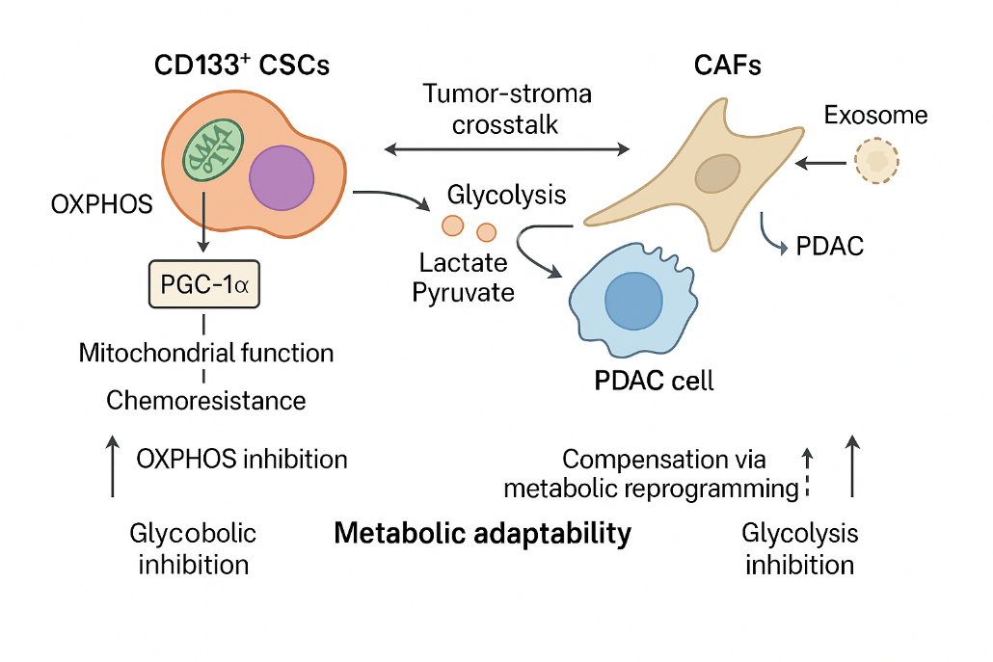

Figure 3. Metabolic adaptability in PDAC through crosstalk between CD133+ cancer stem cells (CSCs), CAFs and tumour cells. CD133+ CSCs primarily depend on OXPHOS driven by PGC-1α–mediated mitochondrial function, which enables them to withstand metabolic stress and contributes to chemoresistance (Li et al., 2023). Inhibiting OXPHOS alone is insufficient as glycolysis inhibition triggers metabolic compensation. CAFs through glycolysis produce lactate and pyruvate fuelling OXPHOS in PDAC cells. This exchange is further enhanced with tumour-derived exosomes that reprogram CAFs to increase nutrient support. Together these tumour stroma-interactions enable PDAC cells to flexibly switch metabolic states sustaining survival under therapeutic stress (Sancho et al., 2015; Li et al., 2023).
Figure generated with the assistance of OpenAI's ChatGPT (2025).

3. Metabolic Reprogramming in PDAC

3.1 Glycolysis & the Warburg Effect 178
A hallmark of PDAC’s metabolic plasticity is its reliance on glycolysis known as Warburg effect, where glucose is converted to lactate even in the presence of oxygen. This shift enables tumours to rapidly generate biosynthesis, prioritising growth over efficient ATP production. This glycolytic phenotype is driven by oncogenic signalling, including KRAS activation and HIF-1 α stabilisation under hypoxia, which together upregulate glucose transporters and glycolytic enzymes (Liberti and Locasale, 2016). These changes enable tumour cells to maintain energy and redox balance in a nutrient-deprived microenvironment (Liberti and Locasale, 2016). As illustrated in Figure 4, PDAC cells coordinate glycolytic flux with other metabolic pathways including pentose phosphate pathway (PPP), nucleotide biosynthesis and glutaminolysis to meet the demands of rapid proliferation (Wang et al., 2022). This rewiring supports not only ATP generation but also resistance to apoptosis and oxidative stress.
Importantly, this preference of glycolysis can be changes under therapeutic or environmental pressure, PDAC cells upregulating OXPHOS as a compensatory mechanism (Dong et al., 2022). This dynamic shift highlights the metabolic plasticity of PDAC and the need for dual targeting strategies to prevent metabolic escape.

3.2 Key Glycolytic Enzymes 337
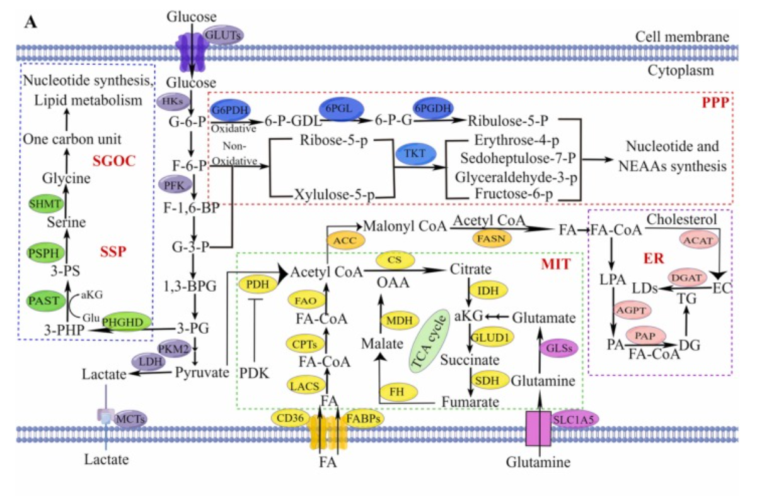Figure 4. Metabolic reprogramming in PDAC highlighting the key enzymes hexokinase 2 (HK2), pyruvate kinase M2 (PKM2), and lactate dehydrogenase A (LDHA), which sustain aerobic glycolysis (Warburg Effect). HK2 catalyses the phosphorylation of glucose to glucose-6-phosphate, driving glycolysis and biosynthesis. PKM2 regulates phosphoenolpyruvate (PEP) conversion to pyruvate, while LDHA converts pyruvate to lactate. Glutaminase (GLS) drives glutaminolysis, producing glutamate and α-ketoglutarate (α-KG) to support the tricarboxylic acid (TCA) cycle. ATP citrate lyase (ACLY) plays a crucial role in the production of acetyl-CoA, thereby regulating the synthesis of cholesterol and fatty acids. The figure also illustrates the pentose phosphate pathway (PPP) and nucleotide biosynthesis, showcasing how PDAC cells coordinate multiple pathways to sustain growth and resist therapy (Wang et al., 2022).

Table 1. Key glycolytic enzymes driving metabolic plasticity in PDAC, by enabling tumour cells to adapt energy production and biosynthesis to harsh conditions, such as hypoxia or chemotherapy. The most critical of these enzymes include hexokinase 2 (HK2), pyruvate kinase M2 (PKM2), and lactate dehydrogenase A (LDHA).

Enzyme | Function in Glycolysis | Role in PDAC | Mechanism Supporting Tumour Growth | Therapeutic Targeting | Key References
HK2 | Converts glucose to glucose-6-phosphate  (first irreversible step) | Overexpressed in PDAC; localised on mitochondria via VDAC | Traps glucose in cell; blocks apoptosis via cytochrome c inhibition | Inhibited by 3-BrPA; microencapsulated form reduces tumour growth and sensitises PCSCs to gemcitabine | Liberti and Locasale (2016); Chapiro et al. (2014); Isayev et al. (2014)
PKM2 | Converts phosphoenolpyruvate (PEP) to pyruvate, producing ATP | Exists as low-activity dimer in PDAC | Promotes anabolic biosynthesis; regulates gene transcription via HIF-1α under hypoxia | Activated by TEPP-46; enhances efficacy of 2-DG in combination therapy | Mohammad et al. (2019); Tee et al. (2017); Angiari et al. (2020)
LDHA | Converts pyruvate to lactate; regenerates NAD⁺ | Overexpressed in PDAC | Increases lactate production; acidifies TME; promotes angiogenesis and immune evasion | Inhibited by FX-11 or siRNA; reduces lactate and increases reactive oxygen species (ROS) | Mohammad et al. (2019); Sancho et al. (2015); Alcalá et al. (2020)

PDAC’s commitment to glycolysis is sustained by upregulation of several enzymes. Based on Table 1, these include hexokinase 2 (HK2), pyruvate kinase M2 (PKM2), and lactate dehydrogenase A (LDHA), all of which play crucial roles in shaping tumour metabolism, survival and therapy resistance.
HK2 initiates glycolysis by catalysing irreversible phosphorylation glucose-6-phosphate, enabling biosynthesis of nucleotides, lipids and amino acids. Uniquely, HK2 is localised to the mitochondria membrane via the voltage-dependent anion channel (VDAC), where it not only facilitates glycolytic flux but also blocks apoptosis by blocking the release of cytochrome c (Liberti and Locasale, 2016). This dual function enables PDAC cells to survive metabolic and therapeutic stress.

While HK2 acts as an entry point of glycolysis, PKM2, catalyses the final step of glycolysis generating one molecule of ATP. Unlike its tetrameric form in normal cells, tumour cells express the dimeric form, which has reduced catalytic activity. Beyond its metabolic role, PKM2 also acts as a transcriptional co-activator with hypoxia-inducible factor-1α (HIF-1α), under hypoxic conditions, upregulating glycolytic genes and suppressing mitochondrial respiration. This regulatory plasticity allows PDAC cells to maintain a more glycolytic phenotype under fluctuating metabolic conditions (Mohammad et al., 2019). This regulatory versatility enhances metabolic plasticity. Although, TEPP-46 can activate PKM2 to restore its tetrameric form, monotherapy has proven insufficient; combination strategies are currently being explored (Angiari et al., 2020).

LDHA catalyses the conversion pyruvate to lactate while oxidising nicotinamide adenine dinucleotide (NADH) to NAD+, enabling continued glycolytic flux (Liberti and Locasale, 2016). Its overexpression in PDAC leads to lactate accumulation and acidification of the TME, which facilitates tumour evasion and the formation of new blood vessels (angiogenesis) (Sancho et al., 2015). While inhibitors such as FX-11 have shown success in preclinical trials, their use as a monotherapy is limited due to the tumour’s ability to compensate via OXPHOS (Moir et al., 2020). However, LDHA’s centrality in regulating metabolic flexibility and redox homeostasis makes it an attractive target.
Beyond their enzymatic functions, these enzymes play a crucial role in PDAC’s ability to switch between glycolysis and OXPHOS (Sancho et al., 2015; Mohammad et al., 2019; Alcalá et al., 2020). This interplay underscores PDAC’s resilience and highlights the rationale to target both pathways, since their individual inhibition often triggers compensatory activation of OXPHOS.

3.3 Mitochondrial Metabolism & OXPHOS 146
While glycolysis dominates in PDAC, many tumour cells retain a functional OXPHOS system enabling them to switch energy resources under metabolic and therapeutic pressure (Sancho et al., 2015). This compensatory shift supports ATP production, redox control and biosynthetic needs when glycolysis is inhibited (Sancho et al., 2015). Figure 5 illustrates OXPHOS occurring via electron transport chain (ETC), comprising the key complexes (I-V) embedded in inner mitochondrial membrane. These complexes are formed by core subunits, which maintain a proton gradient and oxidative metabolism, and show elevated mitochondrial biogenesis and respiratory capacity, especially in therapy resistant or stem-like populations (Li et al., 2023). However, the clinical application of these inhibitors remains limited due to challenges in drug delivery, off-target toxicity and tumour heterogeneity (Masoud et al., 2020; Tsuji et al., 2020). These limitations reinforce the need for combination therapies that target both glycolysis and OXPHOS simultaneously disrupting tumour’s capacity to switch between metabolic states and evade treatment (Aisu et al., 2024). Specific drug targets are further detailed in the accompanying table 2.

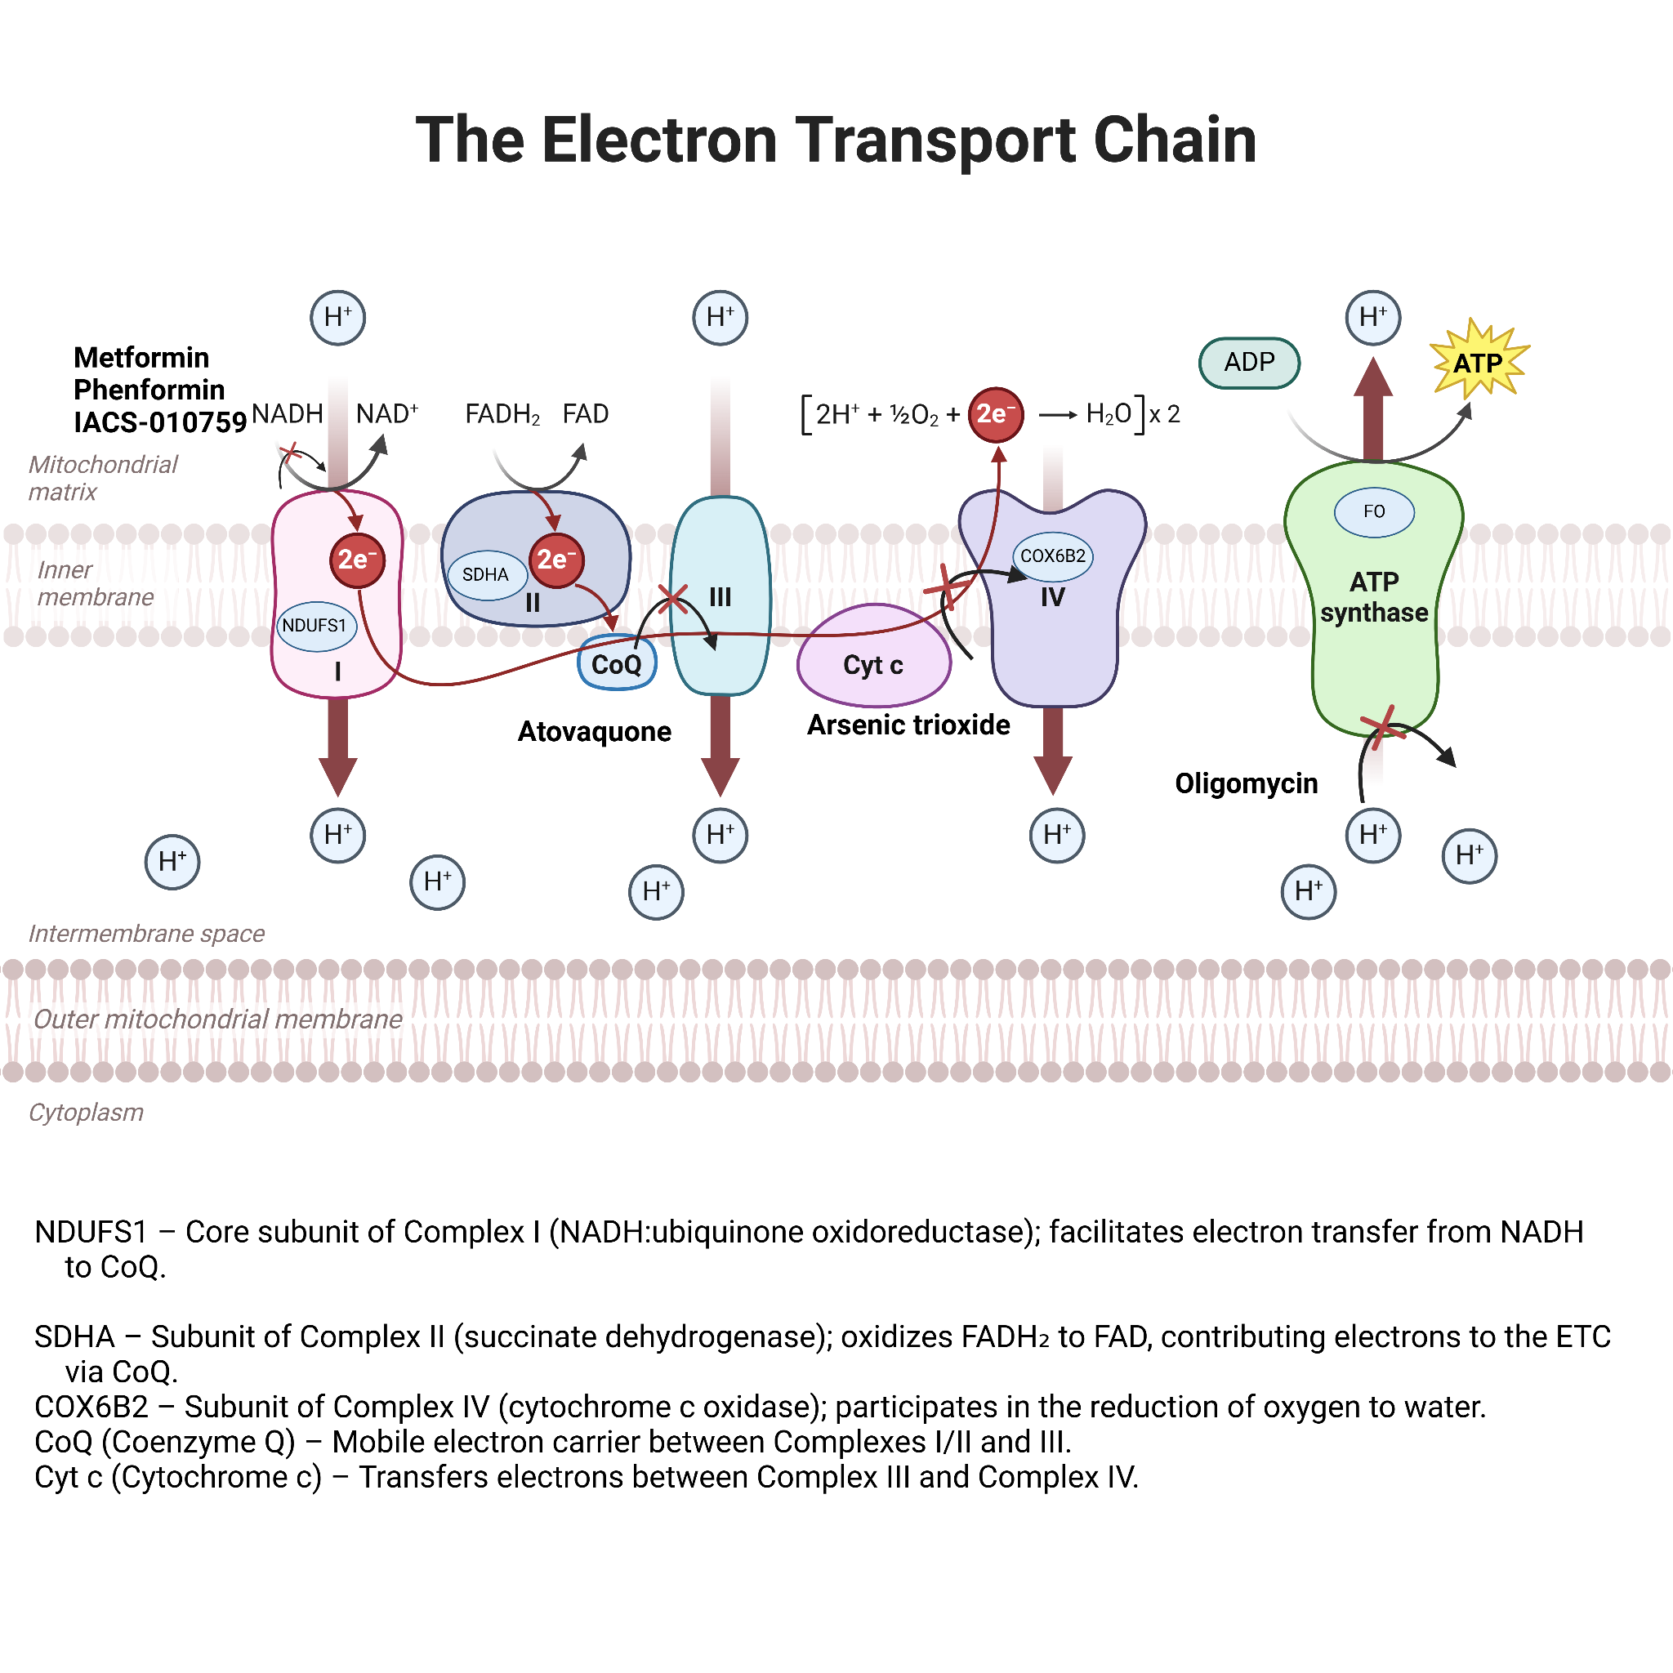
Figure 5. The electron transport chain (ETC) and associated drug targets in PDAC. ETC complexes are shown (Complex I-V) along with representative gene subunits (NDUFS1, SDHA, CoQ, Cyt c, COX6B2, FO). The ETC consists of five membrane bound complexes located in the inner mitochondrial membrane. These complexes maintain proton gradient necessary for ATP production via oxidative phosphorylation (OXPHOS), a process often upregulated in therapy resistant cells. Pharmacological inhibitors targeting these complexes include Metformin, Phenformin, and IACS-010759 inhibit (Complex I), Atovaquone (Complex III), Arsenic trioxide (Complex IV) and Oligomycin (Complex V). Disrupting this pathway can reduce ATP levels, increase ROS and sensitise tumours to glycolytic inhibition. See the legend for gene functions. Created by BioRender.com.

4. Treatment Landscape and Limitations

4.1 Current Conventional Therapies 230
Despite advances in oncology, fewer than 20% of PDAC patients qualify for surgical resection, the only curative option (Sarantis et al., 2020). Even among those who undergo surgery, the recurrence rate remains high, limiting long-term survival. For most patients, systemic chemotherapy, specifically gemcitabine-based regimens, remains the primary treatment. Gemcitabine, a nucleoside analogue, disrupts DNA replication and slows down tumour progression. But its clinical application is limited by intrinsic and acquired resistance mechanisms. Intrinsic resistance refers to pre-existing clinical genetic traits that reduce drug efficacy, whereas acquired resistance develops during treatment as tumour cells adapt upon exposure (Sarantis et al., 2020).
To enhance response rates, FOLFIRINOX combination regimen was developed, incorporating 5-fluorouracil (5-FU), folinic acid, irinotecan, and oxaliplatin, each disrupting DNA synthesis or repair through distinct mechanisms (Table 2). The multidrug approach enhanced the patient outcomes and overall survival compared to gemcitabine alone. However, its intensive profile in severe toxicity, including neutropenia, fatigue, and gastrointestinal disturbances, thus making it suitable only for younger patients (Liu et al., 2018).
While both FOLFIRINOX and gemcitabine regimens offer short-term disease control, their long-term impact is limited (Fan et al., 2024). High recurrence rates and dose-limiting toxicity hinder durable responses. These limitations highlight inadequacy of current cytotoxic approaches in addressing PDAC’s complex resistance mechanisms. As discussed in the following section, one key contributor to treatment failure is chemotherapy-induced metabolic reprogramming, which reinforces the need to integrate metabolic vulnerabilities into future treatment strategies.

Table 2. Mechanisms and side effects of Chemotherapeutic Agents in PDAC treatment. summarised from Anand et al. (2022). This table summarises the drugs, including components of the FOLFIRINOX regimen (5-fluorouracil, leucovorin, irinotecan, and oxaliplatin), as well as gemcitabine, nab-paclitaxel, erlotinib, and cisplatin. Each drug disrupts cellular processes, including DNA synthesis, replication, and repair mechanisms; mitotic division; and receptor-mediated signalling, resulting in a cytotoxic effect against PDAC cells (Anand et al., 2022).

Agent | Mechanism of Action | Side Effects
5-Fluorouracil (5-FU) | A pyrimidine analogue that disrupts DNA synthesis by inhibiting thymidylate synthase, an enzyme required for synthesizing thymidine, a DNA building block. This causes DNA damage and prevents tumour cell replication. | Diarrhea, nausea, vomiting, mouth sores, poor appetite, watery eyes, taste changes, low blood counts, hand-foot syndrome
Leucovorin (folinic acid) | A reduced form of folic acid that stabilises the binding of 5-FU to thymidylate synthase, enhancing its inhibitory effect. This increases the duration and potency of DNA synthesis inhibition. | Rare: skin rash, itching, hives, wheezing
Irinotecan | A topoisomerase I inhibitor that prevents the relaxation of supercoiled DNA during replication. This results in DNA strand breaks, halting the cell cycle and inducing apoptosis in rapidly dividing tumour cells. | Diarrhea (early and late), nausea, vomiting, low white and red blood cell counts, weakness, hair loss, poor appetite, weight loss
Oxaliplatin | A platinum-based compound that forms covalent bonds between DNA strands (intrastrand and interstrand crosslinks). These crosslinks block DNA transcription and replication, ultimately triggering cell death. | Peripheral neuropathy, nausea, vomiting, diarrhea, mouth sores, low blood counts, fatigue, loss of appetite
Gemcitabine | A nucleoside analogue that incorporates into DNA during replication, causing premature chain termination and preventing tumour cell division. | Flu-like symptoms, fever, fatigue, nausea, vomiting, poor appetite, skin rash, low blood counts, liver enzyme changes
Nab-Paclitaxel (Albumin-bound paclitaxel) | A microtubule inhibitor that binds to tubulin preventing its disassembly, thereby halting mitosis and promoting apoptosis in rapidly dividing cells. | Low blood counts, peripheral neuropathy, muscle/joint pain, nausea, vomiting, diarrhea, hair loss
Erlotinib | An EGFR tyrosine kinase inhibitor that blocks EGFR-mediated signalling pathways involved in cell proliferation and survival, often used in cancers with EGFR overexpression. | Diarrhea, rash, dry skin, fatigue, nausea, vomiting, appetite loss, eye irritation
Cisplatin | A platinum-based chemotherapy that forms DNA crosslinks, interfering with DNA replication and transcription, ultimately leading to apoptosis. | Nausea, vomiting, low blood counts, kidney toxicity, ototoxicity, electrolyte imbalance

4.2 Chemotherapy-Induced Metabolic Shifts 273
In addition to resistance, PDAC poses challenges for targeted therapies due to its complex mutational and metabolic landscape. PDAC exhibits significant metabolic heterogeneity, allowing tumour cells to switch between glycolysis and OXPHOS in response to stress (Dong et al., 2022). Cytotoxic regimens such as FOLFIRINOX and gemcitabine not only apply selective pressure but also induce metabolic reprogramming, forcing tumour cells to adapt by enhancing either glycolysis (Warburg effect) or mitochondrial respiration (Zhang et al., 2023). This dual capability allows tumour cells to maintain ATP production, manage oxidative stress and evade therapy-induced damage (Zhang et al., 2023).
Compounding these adaptations, PDAC’s dense stroma and poor vasculature hinger drug penetration, leading to subtherapeutic concentrations within the tumour core (Zhang et al.,2023). This physical barrier is further reinforced by cancer stem cells (CSCs), contributing to treatment failure and relapse by exhibiting both self-renewal and metabolic adaptability (Sancho et al., 2015). Furthermore, early metastasis in PDAC metastasis limits the effectiveness of radiation and surgery (Sarantis et al., 2020).
While combination therapies have been explored to overcome these barriers, their success has been limited (Fan et al., 2024). A meta-analysis comparing twelve chemotherapy protocols reported that median overall survival rarely exceeded seven months with FOLFIRINOX offering modest improvements despite greater toxicity (Liu et al., 2018).
In a more recent study, comparing treatment sequences discovered that B-line regimen (Nab-paclitaxel followed by gemcitabine and then FOLFIRINOX) showed a median survival of 18 months, outperforming other sequences (Table 3) (Fan et al., 2024). However, this improvement did not address the metabolic drivers of resistance or tumour heterogeneity (Fan et al., 2024).
Continued research suggests that chemotherapy itself may drive resistance in pancreatic cells (Zhang et al., 2023). As PDAC can rewire energy pathways under stress, targeting single pathway is often insufficient (Dong et al., 2022). This highlights the need for novel therapeutic strategies to disrupt the metabolic flexibility and overcome its adaptive survival strategies.

Table 3. Summary of survival estimates for PDAC patients undergoing different chemotherapy sequences based on data from Fan et al. (2024). The A-line (red) represents Nab-paclitaxel, followed by gemcitabine, and then FOLFIRINOX. The B-line (green) also consists of these three drugs but in a different sequence. The C-line (purple) involves Nab-paclitaxel and gemcitabine followed by oxaliplatin- or irinotecan-based therapy. Among these, the B-line treatment demonstrated the most extended median survival (18.00 months) with a significantly lower risk of death compared to the A and C-line sequences. This was reflected in a considerably lower hazards ratio, suggesting improved patient outcomes with this treatment sequence.
Treatment Line | Events No. (%) | Median Survival (months, 95% CI) | HR (95% CI) | p log-  rank
B Line (Green, n=37)  vs A-Line | 30 (82%) | 18.00 (15.78 - 20.22) | 0.476 (0.259 - 0.875) | 0.018
A Line (Red, n=37) | 29 (79%) | 14.00 (10.78 - 17.22) | 1 (reference) | -
B Line (Green, n=37)  vs C-Line |  | 18.00 (15.78 - 20.22) | 0.254 (0.126 - 0.513) | 0.040
  30 (82%)
C Line (Purple, n=21) | 21 (100%) | 14.00 (9.56 - 18.45) | 1 (reference) | -

5. Current & Emerging Approaches

5.1 Pharmacological Inhibitors of Glycolysis and OXPHOS 285 377

Table 4. Glycolytic inhibitors and their mechanisms of action in PDAC. This table outlines key categories of inhibitors targeting glycolytic enzymes such as hexokinase 2 (HK2), phosphofructokinase (PFK), pyruvate kinase M2 (PKM2), and lactate dehydrogenase A (LDHA), as well as monocarboxylate transporters (MCT1 and MCT4).The table below shows the categories of inhibitors, targets, mechanisms of action, preclinical or clinical findings( tumour reduction or sensitisation to chemotherapy) from various studies and their known limitations such as off-target effects or poor efficacy as a monotherapy. The table also includes the combination therapies (e.g. 2-DG and Metformin) to demonstrate the synergistic approaches used to overcome metabolic compensation and enhance therapeutic efficiency for PDAC treatment.

Category | Inhibitor | Target | Mechanism of Action | Key Findings | Limitations
Hexokinase (HK) Inhibitors | 3-Bromopyruvate (3-BrPA) | HK2 | Alkylates HK2 disrupt glycolysis and ATP production | Effective in reducing ATP, the microencapsulated form reduces off-target toxicity (Chapiro et al., 2014) | Systemic toxicity in free form requires a delivery system
Phosphofructokinase (PFK) Inhibitors | 2-Deoxy-D-Glucose (2-DG) | PFK | Competes with glucose for phosphorylation, inhibits glycolysis | Enhanced efficacy in p53-mutant PDAC cells, limited as monotherapy (Shukla et al., 2017) | Non-specific inhibition affects normal cells
PKM2 Modulators | TEPP-46 | PKM2 | Activates PKM2 to shift metabolism to lactate production | Failed to reduce ATP/tumour growth alone; effective when combined (Tee et al., 2017; Angiari et al., 2020) | Not effective as monotherapy
LDH Inhibitors | FX-11, Galloflavin | LDHA / LDHB | Blocks pyruvate-to-lactate conversion induces oxidative stress | Significant tumour reduction in combination therapy; limited as monotherapy (Moir et al., 2020) | Limited efficacy in PSC co-culture models
Monocarboxylate Transporter (MCT) Inhibitors | AZD3965 | MCT1 / MCT4 | Blocks lactate transport, forces metabolic crisis | Disrupts CAF–tumour metabolic coupling; enhances therapeutic stress (Benjamin and Hall, 2022) | Lacks PDAC-specific clinical data
Combination Strategies | 2-DG + Metformin, TEPP-46 + FX-11 | PFK + OXPHOS, Glycolysis + LDH | Targets multiple pathways to overcome compensatory metabolism | Combination therapies show superior tumour inhibition with minimal toxicity | Needs more validation in clinical settings

Given the limitations of current chemotherapy, attention has shifted toward disrupting PDAC’s metabolic networks. A key challenge in targeting these pathways is the tumour’s ability to compensate when a single metabolic route is inhibited. As a result, dual targeting of glycolysis and OXPHOS has emerged as a more effective strategy to overcome this adaptability (Aisu et al., 2024.
Glycolytic inhibitors have shown promise, though often only when used in combination., For instance, 2-deoxy-D-glucose (2-DG) showed limited efficacy alone but becomes potent when paired with Ras inhibitor such as salirasib, leading to substantial tumour regression in xenograft models (Goldberg et al., 2012; Xiao et al., 2013). Similarly, 3-bromopyruvate (3-BrPA) enhanced tumour suppression when delivered in its microencapsulated form (β-CD–3-BrPA) (Chapiro et al., 2014). Despite these promising results, the study's limitations include the absence of pharmacokinetic profiling and reliance on a single orthotopic mouse model.
Targeting pyruvate kinase M2 (PKM2) with TEPP-46 alone has been largely ineffective. Specifically, it failed to induce ATP depletion or tumour growth inhibition even in low (5 mM) and high (25 mM) glucose conditions over a 96-hour treatment period (Tee et al., 2017). However, when combined with 2-DG or the LDHA inhibitor FX-11, the combination yielded a synergistic effect, significantly decreasing tumour growth without inducing toxicity (Tee et al., 2017; Moir et al., 2020). These findings emphasise that monotherapies targeting glycolysis are unlikely to succeed in isolation.
Moreover, these dual approaches are supported by mechanistic insights, TEPP-46 increasing PKM2 activity, while FX-11 downregulates LDHA, simultaneously disrupting glycolytic flux and lactate production (Moir et al., 2020). Such combinations not only induce ATP depletion but also elevate oxidative stress pushing cancer cells beyond their compensatory capacity.
Collectively, these findings reinforce the rationale for targeting glycolysis and OXPHOS rather than sequentially or in isolation. As in Table 4, combination strategies consistently outperform single agents, overcoming PDAC’s metabolic compensation and resistance to monotherapy.

Table 5. Overview of key metabolic inhibitors targeting PDAC. The table lists key metabolic regulators and their cellular sources, as well as the pharmacological inhibitors used in PDAC models to target these pathways. Glycolytic inhibitors include 2-deoxy-D-glucose (2-DG), 3-bromopyruvate (3-BrPA), FX-11, and TEPP-46, while mitochondrial metabolism is targeted by metformin, phenformin, IACS-010759 (Complex I), atovaquone (Complex III), arsenic trioxide (Complex IV), and oligomycin (ATP synthase). These inhibitors aim to disrupt the metabolic crosstalk between stromal and tumour cells, thereby reducing therapeutic resistance.
Category | Inhibitor | Target | Mechanism of Action | Key Findings | Limitations
OXPHOS Inhibitors | Metformin | Complex I | Inhibits ETC Complex I; reprograms CAF metabolism | Reprograms CAFs, reduces lactate shuttling and suppresses pro-tumorigenic phenotype (Benjamin and Hall, 2022) | Limited efficacy as monotherapy due to compensatory glycolysis
OXPHOS Inhibitors | Phenformin | Complex I | Inhibits mitochondrial ATP production | Shows synergy with gemcitabine in high-OXPHOS PDAC cells (Masoud et al., 2020) | Risk of lactic acidosis; limited to high-OXPHOS PDAC
OXPHOS Inhibitors | IACS-010759 | Complex I | Inhibits mitochondrial respiration and ATP synthesis | Reduces ATP and tumour volume by 40% (Tsuji et al., 2020) | Neurotoxicity: ineffective due to metabolic compensation
OXPHOS Inhibitors | Atovaquone | Complex III | Disrupts mitochondrial respiration increases ROS | Inhibits CSCs at ~1 µM and reduces oxygen consumption (Fiorillo et al., 2016) | Limited effect on bulk tumour cells
OXPHOS Inhibitors | Arsenic Trioxide (ATO) | Complex IV | Inhibits mitochondrial respiration; sensitises cells to gemcitabine | Combined with gemcitabine, it reduces tumour volume by 65-70% (Tian et al., 2023) | Off-target effects require clinical validation
OXPHOS Inhibitors | Oligomycin | Complex V | Inhibits ATP synthase | Ineffective alone; ATP maintained by glycolytic compensation (Tanton et al., 2018) | It cannot be used as monotherapy due to metabolic plasticity.

To effectively prove PDAC’s reliance on mitochondrial respiration, various OXPHOS inhibitors have been developed, each targeting different complexes of the electron transport chain. (ETC). Among these, metformin attracted attention not only for its inhibition of Complex I but also for its ability to reprogram CAFs (Benjamin and Hall, 2022). By shifting CAF metabolism glycolysis to OXPHOS, metformin reduces lactate production and limit metabolic support to tumour cells (Benjamin and Hall, 2022). However, its monotherapeutic effect is restricted by tumour’s compensatory upregulation of glycolysis limiting sustained efficacy.
To enhance its therapeutic benefit, metformin is studied in combination with lactate transport inhibitors, particularly those targeting monocarboxylate transporters (MCTs) (Benjamin and Hall, 2022). These transporters maintain metabolic symbiosis between CAFs and tumour cells. Simultaneous inhibition disrupts lactate cycling, remodels TME and sensitises PDAC cells to chemotherapy. However, compensatory nutrient pathways such as glutaminolysis can emerge, underscoring the resilience of PDAC metabolism (Benjamin and Hall, 2022).
Phenformin, a more potent biguanide, similarly targets Complex I and shows stronger synergy with gemcitabine in high OXPHOS PDAC cells, reducing viability and enhancing drug response (Masoud et al., 2020). Yet, its clinical use is limited by lactic acidosis risk and variable efficacy across metabolic subtypes highlighting the importance of patient stratification (Masoud et al., 2020).
IACS-010759, another Complex I inhibitor, resulted in a 40% reduction in tumour volume in PDAC models and was associated with substantial ATP depletion and decreased viability (Tsuji et al., 2020). However, the clinical use is challenged by dose-limiting neurotoxicity and metabolic compensation through glycolytic reprogramming, which may reduce its long-term effectiveness (Tsuji et al., 2020). Similarly, inhibitors of downstream complexes, such as Atovaquone targeting Complex III, show preferential activity against CSCs, but are less effective against bulk tumour population, limiting its standalone utility (Fiorillo et al., 2016).
Arsenic trioxide (ATO), which inhibits Complex IV, was found to enhance the effectiveness of gemcitabine in treating PDAC, achieving tumour volume reductions up to 70% (Tian et al., 2023). However, off-target effects and the need for clinical validation remain concerns (Tian et al., 2023).
Lastly, Oligomycin, a Complex V inhibitor, failed to reduce ATP levels, due to compensatory glycolysis., yet showed sensitivity in normal pancreatic acinar cells, emphasising the metabolic adaptability that enables tumour cells to survive mitochondrial inhibition (Tanton et al., 2018).
These findings illustrate that although OXPHOS inhibitors hold therapeutic promise, their success depends on combination strategies that anticipate and counteract metabolic compensation. As summarised in Table 5, no single agent is sufficient, and multi-targeted approaches are essential to fully disrupt the interconnect metabolic networks supporting PDAC survival.

5.2 CRISPR-Based Metabolic Gene Editing 347
Table 6. Potential genes could be targeted via CRISPR-Cas9. The study context, gene function, key findings, and limitations are presented in the table. NDUFS1, SDHA, COX6B2, and the F₀ subunit of ATP synthase (Complex V). Targeting these genes disrupts the mitochondrial mechanism by preventing electron flow, the proton gradient, and ATP production. Specifically, targeting Complex I and V increases reactive oxygen species (ROS), inducing oxidative stress and apoptosis.

Gene Targeted | Study Context | Function | Key Findings | Limitations
NDUFS1 | Gastric and colorectal cancer proposed for PDAC (Xu et al., 2023; Michl et al.,2022) | Complex I subunit catalyses NADH oxidation and initiates ETC | Knockout led to impaired ATP production and enhanced sensitivity to glycolytic inhibition | Delivery to tumour cells remains challenging; it needs tumour-specific vector systems
SDHA | Preclinical and clinical studies in pancreatic neuroendocrine tumours and other SDH-related cancers (Niemeijer et al., 2015) | The subunit of Complex II (succinate dehydrogenase) oxidises FADH2 and feeds electrons into CoQ. | Disruption impairs succinate metabolism ETC input; increases ROS | May have redundant pathways; tumour-specific effects unclear
COX6B2 | Pancreatic ductal adenocarcinoma (PDAC) models (Nie et al., 2020) | The complex IV subunit facilitates electron transfer to oxygen during the final ETC step | Knockdown reduced Complex IV assembly, impaired OXPHOS activity, decreased ATP production, and inhibited metastatic potential in PDAC cells | Limited data on CRISPR knockout; possible compensation by COX6B1 in some tissues

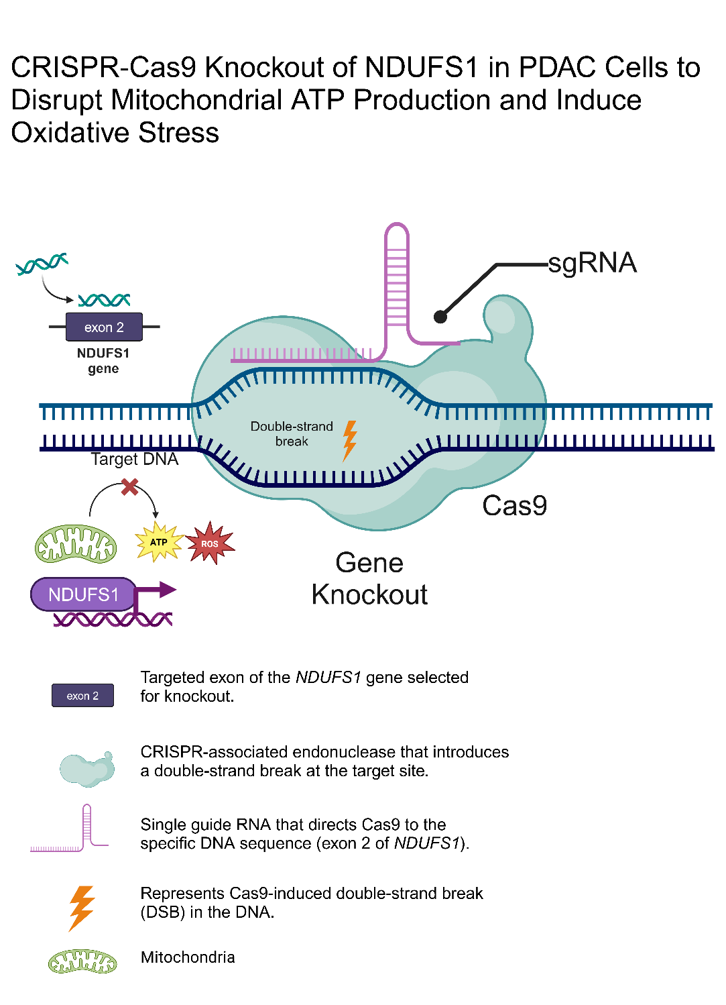
Figure 6. CRISPR (Clustered Regularly Interspaced Short Palindromic Repeats)-Cas9 system to target and knock out NDUFS1 gene in PDAC cells. A single guide RNA (sgRNA) direct Cas9 endonuclease enzyme to exon 2 of the NDUFS1 gene where it introduces double stranded break in DNA, leading to gene knock out. NDUFS1 encodes a core subunit for Complex I in the electron transport chain (ETC). Its loss disrupts electron flow, resulting in reduced ATP production and the accumulated reactive oxygen species (ROS). This process contributes to mitochondrial stress and enhances sensitivity of PDAC to inhibitors. This figure highlights sequential effects of gene editing from DNA targeting to mitochondrial dysfunction. Created using BioRender.com.

While pharmacological inhibitors can disrupt metabolic pathways, they are restricted in terms of incomplete efficacy and compensatory mechanisms. In contrast, gene editing tools such as CRISPR-Cas9, offer a more targeted approach by directly disrupting genes essential for metabolic function. This strategy hold promises in PDAC where metabolic plasticity underlies treatment resistance and tumour survival (Sancho et al., 2015; Michl et al., 2022).
Recent studies have shown that CRISPR-mediated knockouts of OXPHOS-related genes can impair mitochondrial function and sensitise PDAC cells to metabolic stress (Michl et al., 2022; Chen et al., 2023) (Table 6).
When glycolysis is already suppressed, the knockout of NDUFS1 results in immediate ATP depletion in cancer cells, thereby increasing ROS and oxidative stress (Michl et al., 2022). This mechanism is visually summarised in Figure 6, which illustrates CRISPR-Cas9 mediated knockout of NDUFS1 leading to mitochondrial dysfunction, ATP depletion and ROS accumulation. These effects are more pronounced when glycolysis is simultaneously inhibited, as cells are unable to switch energy pathways under dual blockade (Moir et al., 2020).
Supporting data from preclinical models confirm that NDUFS1 knockout significantly sensitises cancer cells to metabolic stress (Chen et al., 2023). Other targets such as SDHA (Complex II) and COX6B2 (Complex IV), also impairs ETC function but their downstream positions allow metabolic bypass or partial compensation (Michl et al., 2022). Consequently, NDUFS1 stands out for its ability to collapse ETC at its initiation point, making it an effective and optimal target for CRISPR-based interventions among all the listed genes (Chen et al., 2023).
However, CRISPR alone is insufficient to prevent metabolic compensation, as tumours reactivate alternative pathways or rely on microenvironmental support to sustain energy production (Sancho et al., 2015; Alcalá et al., 2020). Moreover, the delivery of CRISPR to PDAC cells remains a challenge, requiring tumour-specific vectors to avoid off-target effects and immune responses (Rasul et al., 2022). To overcome these limitations, dual-targeting approaches are being explored (Moir et al., 2020). For instance, combining NDUFS1 knockout with glycolytic inhibitors such as FX-11 has shown enhanced tumour suppression in vivo and vitro (Sancho et al., 2015; Moir et al., 2020). This integrative approach aims to block both pathways simultaneously forcing tumour cells into metabolic collapse.
To sum up, CRISPR based targeting of mitochondrial genes particularly NDUFS1, provides a highly specific and potent strategy to undermine PDAC metabolism. When integrated with pharmacological inhibitors of glycolysis, this dual modality holds strong potential overcoming resistance and improving therapeutic outcomes.

6. Discussion 468
Pancreatic ductal adenocarcinoma (PDAC), exhibit significant metabolic plasticity, allowing cells to switch between glycolysis and oxidative phosphorylation pathways in fluctuating environmental conditions and therapeutic pressures (Dong et al., 2022). This flexibility underpins the therapeutic resistance observed in many cancer treatments, particularly those targeting single metabolic pathways. Aisu et al. (2024) demonstrated a dual inhibition on glycolysis and OXPHOS, achieved synergistic antitumour effect in colorectal and gastric cancer cells, suggesting its applicability to PDAC, which share similar metabolic flexibility.
Among potential OXPHOS targets, NDUFS1, a core unit of Complex I in the ETC stands out for its strategic role in initiating ETC, making it an ideal target for OXPHOS inhibition (Chen et al., 2023). Its disruption leads to ATP depletion and ROS accumulation, triggering mitochondrial dysfunction and cancer cell death (Chen et al., 2023). The inhibition of the gene not only disrupts ATP production but also induces oxidative stress, which is a powerful strategy to sensitise cancer cells to glycolytic inhibition (Moir et al., 2020). Targeting NDUFS1 can have a more immediate and profound effect on mitochondrial function compared to other OXPHOS targets, such as SDHA and COX6B2, which may allow some compensation through different pathways (Michl et al., 2022). Therefore, NDUFS1 stands out as a critical and practical target for combination therapies aimed to disrupt both glycolysis and OXPHOS, which could maximise tumour cell death.
This strategy becomes even more effective when paired with glycolytic inhibitors such as FX-11, which blocks lactate production and force cells to rely on mitochondrial respiration. The dual metabolic inhibition created by inhibiting both pathways has demonstrated synergistic effects in preclinical models (Le et al., 2010). However, compounds like FX-11 and 3-BrPA pose toxicity concerns including their off-target effects on healthy tissues and potential cardiotoxicity (Chapiro et al., 2014). These challenges emphasise the need for more targeted delivery strategies (Wu et al., 2024).
To mitigate these risks, advanced drug delivery systems, such as lipid nanoparticles or exosome-mediated delivery, need to be integrated to improve precision (Wu et al., 2024).
Exosome-based systems show promise for delivering metabolic inhibitors and CRISPR components directly to PDAC cells, reducing the systemic toxicity while increasing their efficacy within the tumour microenvironment (Kim et al., 2023). Moreover, Michl et al. (2022) further validated NDUFS1 as a CRISPR target in PDAC showing that its knockout resulted in disrupted mitochondrial function, increased ROS production and cell death.
Additionally, exosome-mediated CRISPR delivery has proven effective in targeting oncogenes, such as KRASG12D, leading to tumour regression and inhibition of oncogenic signalling pathways (Li et al., 2023). However, permanent CRISPR knock out may also trigger compensatory activation of alternate ETC subunits or stress pathways (Alcalá et al., 2020). To mitigate such risks, gene editing tools such as base editing or prime editing are being developed to enhance specificity and minimise genotoxicity (Carlaw, Zhang and Ross, 2020).
In summary, while dual targeting of metabolic pathways offers a therapeutic potential for PDAC, its success depends on optimising delivery methods and limiting off-target effects. CRISPR-Cas9 mediated targeting of NDUFS1 combined with glycolytic inhibition with FX-11 represents a highly promising strategy to overcome metabolic resistance and improve clinical outcomes.

7. Conclusion 108
The combination of glycolytic inhibitors with CRISPR-Cas9 based OXPHOS targeting represents a highly effective approach to overcoming the metabolic plasticity of PDAC and similar cancers. Specifically, targeting NDUFS1 alongside glycolytic inhibitors, such as FX-11, demonstrated a synergistic effect. However, this approach faces challenges particularly achieving efficient gene delivery and avoiding off-target. To address these limitations, advanced delivery systems such as lipid nanoparticles and exosome-mediated CRISPR therapy are crucial in enhancing the efficacy and safety of these treatments in clinical settings.
While dual inhibition of glycolysis and OXPHOS holds great promise for PDAC therapy, further research is needed to optimise treatment regimens and ensure their clinical feasibility.

8. Acknowledgements
I acknowledge that I used ChatGPT to refine the structure of my dissertation. The tool was strictly used for editorial purposes and not for generating synthesis or analysis. Figure 5 and 6 were created by me using BioRender.com. Additionally, Figure 1 was adapted from a publicly available BioRender template with appropriate citation included in the figure caption. Figure 3 was generated with the assistance of OpenAI’s ChatGPT (2025) and is also credited in the figure caption.

9. References
Alcalá, S., Sancho, P., Martinelli, P., Navarro, D.A., Pedrero, C., Martin-Hijano, L., Valle, S.C., Earl, J., Rodríguez-Serrano, M., Ruiz-Cañas, L., Rojas, K.I., Carrato, A., García-Bermejo, M.L., Fernández-Moreno, M.Á., Hermann, P.C., & Sainz, B. (2020). ISG15 and ISGylation are required for pancreatic cancer stem cell mitophagy and metabolic plasticity. Nature Communications, 11(1), Article 16395. https://doi.org/10.1038/s41467-020-16395-2.

Angiari, S., Runtsch, M.C., Sutton, C.E., Palsson-McDermott, E.M., Kelly, B., Rana, N., Kane, H., Papadopoulou, G., Pearce, E.L., Mills, K.H.G., & O’Neill, L.A.J. (2020). Pharmacological activation of pyruvate kinase M2 inhibits CD4+ T cell pathogenicity and suppresses autoimmunity. Cell Metabolism, 31(2), 391–405.e8. https://doi.org/10.1016/j.cmet.2019.10.015.

Aisu, Y., Oshima, N., Hyodo, F., Elhelaly, A.E., Masuo, A., Okada, T., Hisamori, S., Tsunoda, S., Hida, K., Morimoto, T., Miyoshi, H., Taketo, M.M., Neckers, L.M., Sakai, Y., & Obama, K. (2024). Dual inhibition of oxidative phosphorylation and glycolysis exerts a synergistic antitumor effect on colorectal and gastric cancer by creating energy depletion and preventing metabolic switch. PLoS ONE, 19(12), e0309700. https://doi.org/10.1371/journal.pone.0309700.

Anand, U., Dey, A., Chandel, A.K.S., Sanyal, R., Mishra, A., Pandey, D.K., De Falco, V., Upadhyay, A., Kandimalla, R., Chaudhary, A., Dhanjal, J.K., Dewanjee, S., Vallamkondu, J. and Pérez de la Lastra, J.M., 2022. Cancer chemotherapy and beyond: Current status, drug candidates, associated risks and progress in targeted therapeutics. Genes & Diseases, 10(4), pp.1367–1401. https://doi.org/10.1016/j.gendis.2022.02.007

Benjamin, D., & Hall, M.N. (2022). Combining metformin with lactate transport inhibitors as a treatment modality for cancer—recommendation proposal. Frontiers in Oncology, 12, Article 1034397. https://doi.org/10.3389/fonc.2022.1034397.

Bonomo, R. (2024). Stages of pancreatic cancer and treatment options. Biorender.com. Available at: https://app.biorender.com/biorender-templates/figures/all/t-66839cad01e22a3d930af1a5-stages-of-pancreatic-cancer-and-treatment-options [Accessed 24 Mar. 2025].

Butera, G., Pacchiana, R., Mullappilly, N., Margiotta, M., Bruno, S., Conti, P., Riganti, C., & Donadelli, M. (2018). Mutant p53 prevents GAPDH nuclear translocation in pancreatic cancer cells favoring glycolysis and 2-deoxyglucose sensitivity. Biochimica et Biophysica Acta (BBA) - Molecular Cell Research, 1865(12), 1914–1923. https://doi.org/10.1016/j.bbamcr.2018.10.005.
Carlaw, T.M., Zhang, L.-H. and Ross, C.J.D., (2020). CRISPR/Cas9 editing: Sparking discussion on safety in light of the need for new therapeutics. Human Gene Therapy, 31(15–16), pp.794–807. https://doi.org/10.1089/hum.2020.111

Chapiro, J., Sur, S., Savic, L.J., Ganapathy-Kanniappan, S., Reyes, J., Duran, R., Thiruganasambandam, S.C., Moats, C.R., Lin, M., Luo, W., Tran, P.T., Herman, J.M., Semenza, G.L., Ewald, A.J., Vogelstein, B., & Geschwind, J.-F. (2014). Systemic delivery of microencapsulated 3-bromopyruvate for the therapy of pancreatic cancer. Clinical Cancer Research, 20(24), 6406–6417. https://doi.org/10.1158/1078-0432.ccr-14-1271.

Chen, T., Li, D., Wang, Y., Shen, X., Dong, A., Dong, C., Duan, K., Ren, J., Li, W., Shu, G., Yang, J., Xie, Y., Qian, F., & Zhou, J. (2023). Loss of NDUFS1 promotes gastric cancer progression by activating the mitochondrial ROS-HIF1α-FBLN5 signaling pathway. British Journal of Cancer, 129(8), 1261–1273. https://doi.org/10.1038/s41416-023-02409-5.

Dong, S., Li, W., Li, X., Wang, Z., Chen, Z., Shi, H., He, R., Chen, C., & Zhou, W. (2022). Glucose metabolism and tumour microenvironment in pancreatic cancer: A key link in cancer progression. Frontiers in Immunology, 13, Article 1038650. https://doi.org/10.3389/fimmu.2022.1038650.

Fan, M., Deng, G., Ma, Y., Si, H., Wang, Z., & Dai, G. (2024). Survival outcome of different treatment sequences in patients with locally advanced and metastatic pancreatic cancer. BMC Cancer, 24(1), Article 11823. https://doi.org/10.1186/s12885-024-11823-8.

Fiorillo, M., Lamb, R., Tanowitz, H.B., Mutti, L., Krstic-Demonacos, M., Cappello, A.R., Martinez-Outschoorn, U.E., Sotgia, F., & Lisanti, M.P. (2016). Repurposing atovaquone: Targeting mitochondrial complex III and OXPHOS to eradicate cancer stem cells. Oncotarget, 7(23), 34084–34099. https://doi.org/10.18632/oncotarget.9122.

Fu, Y., Liu, S., Zeng, S. and Shen, H. (2018). The critical roles of activated stellate cells-mediated paracrine signaling, metabolism and onco-immunology in pancreatic ductal adenocarcinoma. Molecular Cancer, [online] 17(1). doi:https://doi.org/10.1186/s12943-018-0815-z.

Goldberg, L., Israeli, R., & Kloog, Y. (2012). FTS and 2-DG induce pancreatic cancer cell death and tumour shrinkage in mice. Cell Death & Disease, 3(3), Article e284. https://doi.org/10.1038/cddis.2012.24.

Hu, L.-P., Zhang, X.-X., Jiang, S.-H., Tao, L.-Y., Li, Q., Zhu, L.-L., Yang, M.-W., Huo, Y.-M., Jiang, Y.-S., Tian, G.-A., Cao, X.-Y., Zhang, Y.-L., Yang, Q., Yang, X.-M., Wang, Y.-H., Li, J., Xiao, G.G., Sun, Y.-W., Zhang, Z.-G. (2019). Targeting purinergic receptor P2Y2 prevents the growth of pancreatic ductal adenocarcinoma by inhibiting cancer cell glycolysis. Clinical Cancer Research, 25(4), 1318–1330. https://doi.org/10.1158/1078-0432.ccr-18-2297.

Kitamura, F., Semba, T., Yasuda-Yoshihara, N., Yamada, K., Nishimura, A., Yamasaki, J., Nagano, O., Yasuda, T., Yonemura, A., Tong, Y., Wang, H., Akiyama, T., Matsumura, K., Uemura, N., Itoyama, R., Bu, L., Fu, L., Hu, X., Wei, F., & Mima, K. (2023). Cancer-associated fibroblasts reuse cancer-derived lactate to maintain a fibrotic and immunosuppressive microenvironment in pancreatic cancer. JCI Insight, 8(20), Article e163022. https://doi.org/10.1172/jci.insight.163022.

Li, X., Zhou, J., Wang, X., Li, C., Ma, Z., Wan, Q., & Peng, F. (2023). Pancreatic cancer and fibrosis: Targeting metabolic reprogramming and crosstalk of cancer-associated fibroblasts in the tumor microenvironment. Frontiers in Immunology, 14. https://doi.org/10.3389/fimmu.2023.1152312.
Liberti, M.V., & Locasale, J.W. (2016). The Warburg effect: How does it benefit cancer cells? Trends in Biochemical Sciences, 41(3), 211–218. https://doi.org/10.1016/j.tibs.2015.12.001.
Liu, G.-F., Li, G.-J., & Zhao, H. (2018). Efficacy and toxicity of different chemotherapy regimens in the treatment of advanced or metastatic pancreatic cancer: A network meta-analysis. Journal of Cellular Biochemistry, 119(1), 511–523. https://doi.org/10.1002/jcb.26210.
Masoud, R., Reyes-Castellanos, G., Lac, S., Garcia, J., Dou, S., Shintu, L., Abdel Hadi, N., Gicquel, T., El Kaoutari, A., Diémé, B., Tranchida, F., Cormareche, L., Borge, L., Gayet, O., Pasquier, E., Dusetti, N., Iovanna, J., & Carrier, A. (2020). Targeting mitochondrial complex I overcomes chemoresistance in high OXPHOS pancreatic cancer. Cell Reports Medicine, 1(8), Article 100143. https://doi.org/10.1016/j.xcrm.2020.100143.
Michl, J., Wang, Y., Monterisi, S., Blaszczak, W., Beveridge, R., Bridges, E.M., Koth, J., Bodmer, W.F., & Swietach, P. (2022). CRISPR-Cas9 screen identifies oxidative phosphorylation as essential for cancer cell survival at low extracellular pH. Cell Reports, 38(10), Article 110493. https://doi.org/10.1016/j.celrep.2022.110493.
Mohammad, G.H., Vassileva, V., Acedo, P., Olde Damink, S.W.M., Malago, M., Dhar, D.K., & Pereira, S.P. (2019). Targeting pyruvate kinase M2 and lactate dehydrogenase A is an effective combination strategy for the treatment of pancreatic cancer. Cancers, 11(9), Article 1372. https://doi.org/10.3390/cancers11091372.
Moir, J.A.G., Long, A., Haugk, B., French, J.J., Charnley, R.M., Manas, D.M., Wedge, S.R., Mann, J., Robinson, S.M., & White, S.A. (2020). Therapeutic strategies toward lactate dehydrogenase within the tumor microenvironment of pancreatic cancer. Pancreas, 49(10), 1364–1371. https://doi.org/10.1097/mpa.0000000000001689.
Niemeijer, N.D., Papathomas, T.V., Korpershoek, E., Ronald, R., Oudijk, L., Morreau, H., Bayley, J.-P., Hes, F.J., Jansen, J.P., Dinjens, W.N.M., & Corssmit, E.P.M. (2015). Succinate dehydrogenase (SDH)-deficient pancreatic neuroendocrine tumor expands the SDH-related tumor spectrum. The Journal of Clinical Endocrinology & Metabolism, 100(10), E1386–E1393. https://doi.org/10.1210/jc.2015-2689.
OpenAI. (2025). ChatGPT. Available at: https://chat.openai.com/ [Accessed 24 Mar. 2025].
Isayev, O., Rausch, V., Bauer, N., Liu, L., Fan, P., Zhang, Y., Gladkich, N.J., Nwaeburu, C.C., Mattern, J., Mollenhauer, M., Rückert, F., Zach, S., Haberkorn, U., Gross, W., Schönsiegel, F., Bazhin, A.V., & Herr, I. (2014). Inhibition of glucose turnover by 3-bromopyruvate counteracts pancreatic cancer stem cell features and sensitizes cells to gemcitabine. Oncotarget, 5(13), 5177–5189. https://doi.org/10.18632/oncotarget.2120.
Raez, L.E., Papadopoulos, K., Ricart, A.D., Chiorean, E.G., DiPaola, R.S., Stein, M.N., Rocha Lima, C.M., Schlesselman, J.J., Tolba, K., Langmuir, V.K., Kroll, S., Jung, D.T., Kurtoglu, M., Rosenblatt, J., & Lampidis, T.J. (2012). A phase I dose-escalation trial of 2-deoxy-D-glucose alone or combined with docetaxel in patients with advanced solid tumors. Cancer Chemotherapy & Pharmacology, 71(2), 523–530. https://doi.org/10.1007/s00280-012-2045-1.
Rasul, M.F., Wu, X., Yang, X. and Su, J., 2022. Strategies to overcome the main challenges of the use of CRISPR/Cas9 as a replacement for cancer therapy. Molecular Cancer, 21(1), p.1. https://doi.org/10.1186/s12943-021-01487-4
Sancho, P., Burgos-Ramos, E., Tavera, A., Bou Kheir, T., Jagust, P., Schoenhals, M., Barneda, D., Sellers, K., Campos-Olivas, R., Graña, O., Viera, C.R., Yuneva, M., Sainz, B., & Heeschen, C. (2015). MYC/PGC-1α balance determines the metabolic phenotype and plasticity of pancreatic cancer stem cells. Cell Metabolism, 22(4), 590–605. https://doi.org/10.1016/j.cmet.2015.08.015.
Sarantis, P., Koustas, E., Papadimitropoulou, A., Papavassiliou, A.G., & Karamouzis, M.V. (2020). Pancreatic ductal adenocarcinoma: Treatment hurdles, tumor microenvironment, and immunotherapy. World Journal of Gastrointestinal Oncology, 12(2), 173–181. https://doi.org/10.4251/wjgo.v12.i2.173.
Shukla, S.K., Purohit, V., Mehla, K., Gunda, V., Chaika, N.V., Vernucci, E., King, R.J., Abrego, J., Goode, G.D., Dasgupta, A., Illies, A.L., Gebregiworgis, T., Dai, B., Augustine, J.J., Murthy, D., Attri, K.S., Mashadova, O., Grandgenett, P.M., Powers, R., & Ly, Q.P. (2017). MUC1 and HIF-1α signaling crosstalk induces anabolic glucose metabolism to impart gemcitabine resistance to pancreatic cancer. Cancer Cell, 32(1), 71–87.e7. https://doi.org/10.1016/j.ccell.2017.06.004.
Tee, S.S., Park, J.M., Hurd, R.E., Brimacombe, K.R., Boxer, M.B., Massoud, T.F., Rutt, B.K., & Spielman, D.M. (2017). PKM2 activation sensitizes cancer cells to growth inhibition by 2-deoxy-D-glucose. Oncotarget, 8(53), 90959–90968. https://doi.org/10.18632/oncotarget.19630.
Tanton, H., Voronina, S., Evans, A., Armstrong, J., Sutton, R., Criddle, D.N., Haynes, L., Schmid, M.C., Campbell, F., Costello, E., & Tepikin, A.V. (2018). F1F0-ATP Synthase Inhibitory Factor 1 in the Normal Pancreas and in Pancreatic Ductal Adenocarcinoma: Effects on Bioenergetics, Invasion, and Proliferation. Frontiers in Physiology, 9. https://doi.org/10.3389/fphys.2018.00833.
Tian, Z., Tan, Y., Lin, X., Su, M., Pan, L., Lin, L., Ou, G., & Chen, Y. (2023). Arsenic trioxide sensitizes pancreatic cancer cells to gemcitabine through downregulation of the TIMP1/PI3K/AKT/mTOR axis. Translational Research: The Journal of Laboratory and Clinical Medicine, 255, 66–76. https://doi.org/10.1016/j.trsl.2022.11.007.
Tsuji, A., Akao, T., Masuya, T., Murai, M., & Miyoshi, H. (2020). IACS-010759, a potent inhibitor of glycolysis-deficient hypoxic tumor cells, inhibits mitochondrial respiratory complex I through a unique mechanism. Journal of Biological Chemistry, 295(21), 7481–7491. https://doi.org/10.1074/jbc.ra120.013366.
Vasseur, S., Tomasini, R., Tournaire, R., & Iovanna, J.L. (2010). Hypoxia induced tumor metabolic switch contributes to pancreatic cancer aggressiveness. Cancers, 2(4), 2138–2152. https://doi.org/10.3390/cancers2042138.
Wang, D., Wang, F., Kong, X., Li, Q., Shi, H., Zhao, S., Li, W., Li, Y., & Meng, J. (2022). The role of metabolic reprogramming in cancer metastasis and potential mechanism of traditional Chinese medicine intervention. Biomedicine & Pharmacotherapy, 153, Article 113376. https://doi.org/10.1016/j.biopha.2022.113376.
Wu, B., Wang, Z., Liu, J., Li, N., Wang, X., Bai, H., Wang, C., Shi, J., Zhang, S., Song, J., Li, Y., & Nie, G. (2024). Dual rectification of metabolism abnormality in pancreatic cancer by a programmed nanomedicine. Nature Communications, 15(1). https://doi.org/10.1038/s41467-024-54963-y.
Xiao, H., Li, S., Zhang, D., Liu, T., Yu, M., & Wang, F. (2012). Separate and concurrent use of 2-deoxy-D-glucose and 3-bromopyruvate in pancreatic cancer cells. Oncology Reports, 29(1), 329–334. https://doi.org/10.3892/or.2012.2085.
Xu, Y., Xue, D., Kyani, A., Bankhead, A., Roy, J., Ljungman, M., & Neamati, N. (2023). First-in-class NADH/ubiquinone oxidoreductase core subunit S7 (NDUFS7) antagonist for the treatment of pancreatic cancer. PubMed, 6(8), 1164–1181. https://doi.org/10.1021/acsptsci.3c00069.
Zhang, F., Ma, Y., Li, D., Wei, J., Chen, K., Zhang, E., Liu, G., Chu, X., Liu, X., Liu, W., Tian, X., & Yang, Y. (2024). Cancer-associated fibroblasts and metabolic reprogramming: unraveling the intricate crosstalk in tumor evolution. Journal of Hematology & Oncology, 17(1). https://doi.org/10.1186/s13045-024-01600-2.
Zhang, J., Wang, Y., Wang, L., You, L., & Zhang, T. (2023). Pancreatic ductal adenocarcinoma chemoresistance: From metabolism reprogramming to novel treatment. Chinese Medical Journal, 137(4), 408–420. https://doi.org/10.1097/cm9.0000000000002758.

